See below the 32nd Youth Governor’s post 2026 YP newsletter!

Good afternoon Youth Parliament Alumni,

We did it! There were a very hectic few weeks after the last time you heard from us, but the 31st WA Youth Parliament successfully completed their sitting week in July.

We had a BIG week of debating, laughing, (crying), last minute speech writing, and just generally making memories. This years cohort was spirited to say the least! I had so much fun watching the passion and drive of our Youth Parliamentarians this year, and really enjoyed the diverse topics that each committee covered. It's always an absolute privilege to sit in the Legislative Assembly and watch 59 young people fight for the change they want to see in WA.

ICYMI - Outcomes of the Bills were as follows:

First Nations Cultural and Economic Empowerment Bill - Ayes 33, Noes 22

Carers and Guardians Support Bill - Ayes 50, Noes 3

Education and Student Wellbeing Reform Bill - Ayes 32, Noes 21

Fuel Infrastructure and Energy for Regional Community Equality Bill - Ayes 22, Noes 31

Western Australian Accommodation Crisis Bill - Ayes 42, Noes 12

Rolling-stock Overhaul and Drivers Safety Bill - Ayes 54, Noes 0

Family Violence Restraining Order Reform and Review Bill - Ayes 32, Noes 16

State Battery Industry Development Bill - Ayes 27, Noes 28

Since camp ended, we have debriefed, wrapped up, and also welcomed our 2027 Taskforce! We have some exciting new faces to introduce you to this year and I can't wait to work with them all to continue to grow this program, but you'll have to keep an eye on our socials to learn more.

I want to say a big thank you to our outgoing taskforce members, including our 31st Youth Governor Luke Commins. Luke was a part of Youth Parliament for 4 years and made a massive impact on the program. Thanks for all your work, Luke.

Other goodbyes include:
- Aimee Oliver
- Josh Zilani
- Ananya Sachidanandan
- Ella Taylor
Thank you all for your contributions to the program, you will all be missed!!

I'd also like to take this opportunity to properly introduce myself. My name is Olivia (or Liv) and I am the 32nd WA Youth Governor. You will be hearing from me over the next year about all things Youth Parliament. I've written a little biography below for you to read if you're interested in knowing a bit more about me.

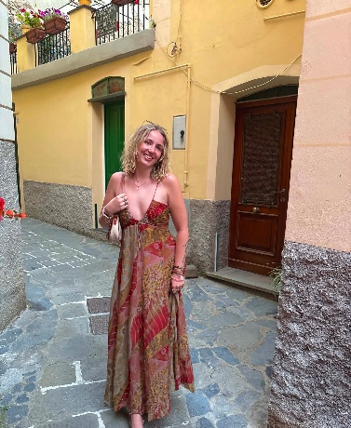
About Liv
I am 21 years old and was born and half-raised in England. I moved to Boorloo (Perth) with my family in 2013, to be closer to my Dad's family in Melbourne. I am passionate about empowering young people and working with Mob to improve outcomes for Aboriginal people, especially children and young people.
I also volunteer for an organisation called What Were You Wearing Australia which is an Indigenous, youth led charity fighting to end sexual violence in Australia.
Cheeky plug, but we are currently looking for Expressions of Interest from young people (ages 15-25) who may want to join our Youth Advisory Council - find out more here https://wwywaus.org/youth-advisory-counsil

Looking forward to keeping you all up to date for this 32nd year of WA Youth Parliament and hopefully seeing you all at some alumni events this year!

Many thanks,
Liv

